**Name : ID:**

**Lab # 4: Implementation of Conditional Statements (B)**

**OBJECTIVES**

In this lab you will learn:

- the use of Conditional Statements

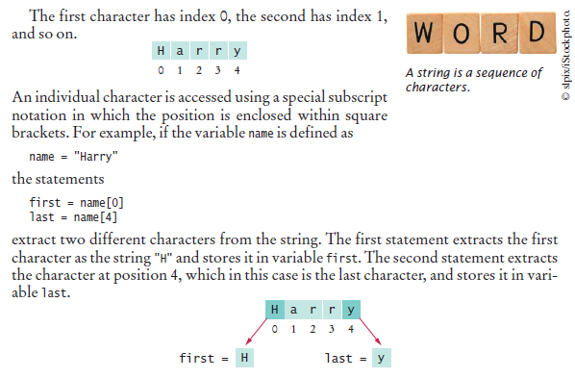

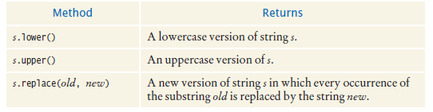

**Code:**

name = "Programming Fundamentals"  
uppercaseName = name.upper()  
print(uppercaseName)  
print(name.lower())  
name2 = name.replace("Programming", "Basic")  
print(name2)

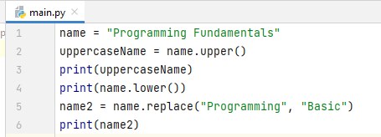

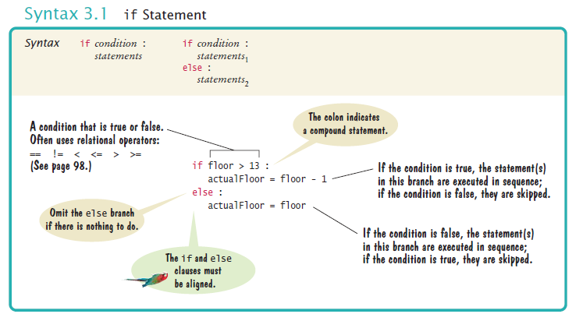

**Task 1**

A Computer shop has announced sale, giving an 7 percent discount on all computer accessory purchases if the price is less than PKR 12,800, and a 19 percent discount if the price is at least PKR 12,800. Write a program that asks the cashier for the original price and then prints the discounted price.

**Nested Branches**

* When a decision statement is contained inside the branch of another decision statement, the statements are nested. Nested decisions are required for problems that have multiple levels of decision making.

**Task 2**

When two points in time are compared, each given as hours (in military time, ranging from 0 to 23) and minutes, the following pseudocode determines which comes first.

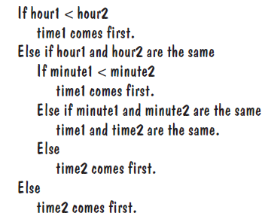

Write a program that prompts the user for two points in time and prints the time that comes first, then the other time.

**Task 3**

Write a program that translates a letter grade into a number grade.

1. Letter grades are A, B, C, D, and F, possibly followed by + or –.
2. Their numeric values are 4, 3, 2, 1, and 0.
3. There is no F+ or F–.
4. A + increases the numeric value by 0.3, a – decreases it by 0.3.
5. However, an A+ has value 4.0.

**Task 4**

Write a program that computes taxes for the following schedule.

|  |  |  |  |
| --- | --- | --- | --- |
| **If your status is Single and**  **if the taxable income is over** | **but not over** | **the tax is** | **of the amount over** |
| PKR 0 | PKR 50,000 | 15 % | PKR 0 |
| PKR 50,000 | PKR 100,000 | PKR 900 + 15 % | PKR 50,000 |
| PKR 100,000 |  | PKR 7,500 + 22 % | PKR 100,000 |
| **If your status is Married and if the taxable income is over** | **but not over** | **the tax is** | **of the amount over** |
| PKR 0 | PKR 80,000 | 15 % | PKR 0 |
| PKR 80,000 | PKR 130,000 | PKR 1,800 + 15 % | PKR 80,000 |
| PKR 130,000 |  | PKR 10,000 + 22 % | PKR 130,000 |